Digestion and absorption

The gastrointestinal tract (G.I.T)
The principle function of the gastrointestinal tract and its associated organs is the digestion and absorption of nutrient. The major foods are ingested as macromolecules (carbohydrate, proteins, lipids and nucleic acids), which must be broken down to small components for absorption. This is achieved by enzymes hydrolases secreted by the G.I.T, together with the mechanical process involve in digestion. The digestive sequence is controlled by neural and hormonal factors and the gut is an active endocrine organ.
Protein amino acid
Starch monosaccharides
triglycerides monoacylglycerol, glycerol and fatty acid

Digestion: A process of converting complicated compounds from the insoluble, non-diffusible state into simple products of higher solubility and great diffusiblity making easier absorption for utilization by tissue
The important digestive secretion are(daily)
secretion | Vol (ml) | pH
Salivary secretion | 1000 | 6.8
Gastric juice | 1500 | 1-3.5
Pancreatic juice | 1000 | 8-8.3
Bile juice | 1000 | 7.8
Intestinal juice | 1800 | 7.5-8

Metabolism:

Is the network of chemical reactions that occur inside the body (within the cell). It describes all biochemical reactions occurring in the cell exchanging matter and energy between the cell and its environment.

Metabolites are the small molecules that are intermediates in the degradation or biosynthesis of biopolymers. The term intermediary metabolism is applied to the reactions involving these low-molecular-weight molecules.
Metabolic pathways fall into three categories:

- Anabolic pathways which are those involved in the synthesis of large and more complex compounds from small molecules for example synthesis of protein from amino acids, synthesis of glycogen from carbohydrates and nucleic acid. Free energy is required for these processes.

- Catabolic pathways which are involved in the breakdown of large molecules into small molecules, therefore, it is the process of degradation (it can be absorbed and metabolized) for example the respiratory chain and oxidative phosphorylation).

- Amphibolic pathways which occur at the crossroad of metabolism, acting as links between the anabolic and catabolic pathways

After digestion, the simple food materials pass into the cells by a process called “absorption”. So the first part of metabolism is the digestion & absorption.
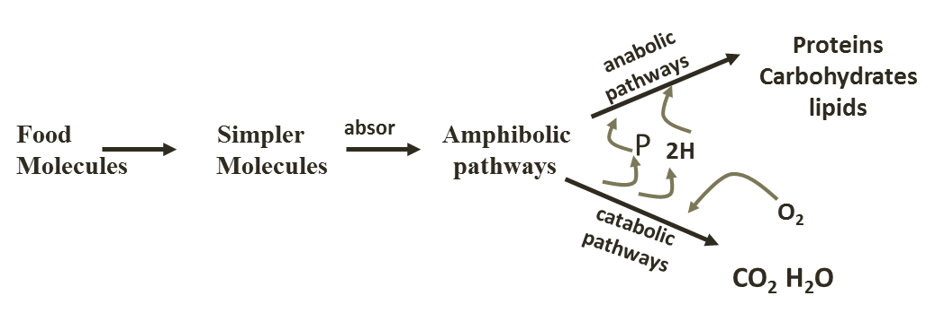

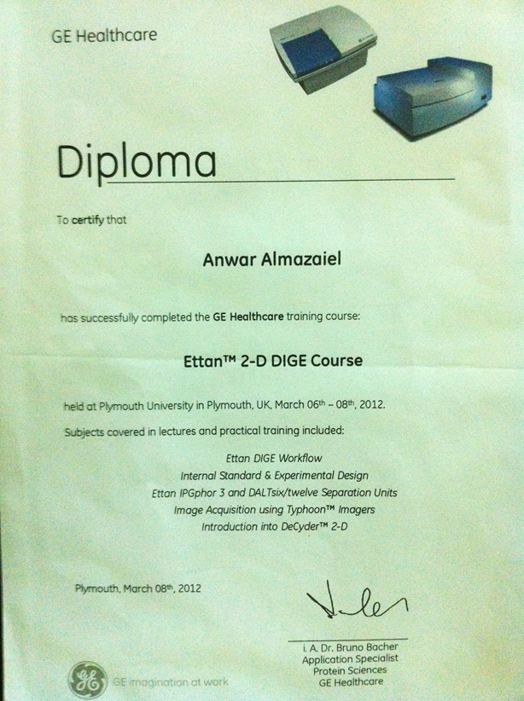
الاسم: د. انوارجاسب ثعبان
من قبل diploma نيل شهادة
في استخدام التقنية في الكورس التدريبي في الجامعة البريطانية بلمث GE health care
Ettan^{2TM} 2-D DIGE
وهي تقنية تستخدم على نطاق واسع لتحليل وفصل خليط البروتينات المعقدة المستخلصة من الخلايا والأنسجة ، أواي عينات بيولوجية أخرى .

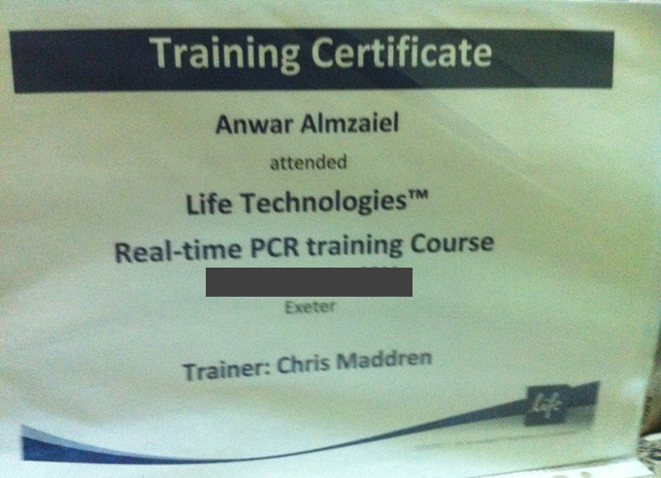

الاسم: د. انوارجاسب ثعبان
قبل من نيل شهادة في الكورس التدريبي
في استخدام تقنية بريطانيا في life technologiesTM
لدراسة التغييرات الجينية كمؤشرات بايلوجية في مختلف الامراض Real-time PCR

